**3D (Continuation)**

**Primitive Solids**

**Box | Sphere | Cylinder | Cone | Wedge | Torus | Pyramid | Polysolid**

For this lesson, you should switch to the 3D modelling workspace. Look for the icon in the bottom right of the AutoCAD screen.

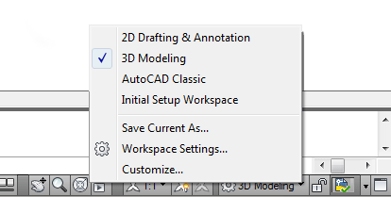

**What is a Primitive Solid?**

A primitive solid is a ‘building block' that you can use to work with in 3D. Rather than extruding or revolving an object, AutoCAD has some basic 3D shape commands at your disposal. From these basic primitives, you can start building your 3D models. In many cases, you get the same result from drawing circles and rectangles and then extruding them, but doing it one command is generally faster. Using these with Boolean operations can be a very effective way of drawing in 3D. There are eight different primitives that you can choose from and are on the Home >Modelling Tool Panel (when in the 3D workspace).

(Click on the **ICON** below to go to the command)

|  |  |  |  |
| --- | --- | --- | --- |
| **SHAPE** | **COMMAND** | **ICON** | **DESCRIPTION** |
| BOX | BOX | Box Icon | Creates a solid box after you provide 2 opposite corners and a height. |
| SPHERE | SPHERE | Sphere Icon | Creates a solid sphere from a center point and radius. |
| CYLINDER | CYLINDER | Cylinder Icon | Creates a straight cylinder from a center point, radius and height. |
| CONE | CONE | Cone Icon | Creates a tapered cone from a center point, radius and height. |
| WEDGE | WEDGE | Wedge Icon | Creates a triangular wedge from 2 opposite points. |
| TORUS | TORUS | Torus Icon | Creates a torus (donut shape) based on center point, radius and tube radius. |
| PYRAMID | PYRAMID / PYR | Polysolid Icon | Draws a solid object with a polygon (3-32 sides) base that rises to a central point. |
| POLYSOLID | PSOLID | Polysolid Icon | Draws a solid object with width and height as you would draw a polyline. |

You can use primitives to either begin building a model, or it can even be a finished object on its own. Many of these commands are similar to 2D commands, except with an extra coordinate in the Z axis. Here is a summary of working with these commands.

**Box**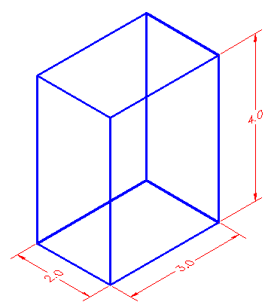

Think of a box as an extruded rectangle. It has width, height and depth. It is created by establishing a starting corner and then establishing a second corner by either picking or giving relative coordinates.

Here is an example of this:

Command: box  
Specify corner of box or [Center]: 2,3,4  
Specify corner or [Cube/Length]: @5,7,10

This draws a box that is 5 units in the X-axis wide, 7 units long in the Y-axis and has a depth of 10 units in the positive Z-axis with one corner located at 2,3,4.

Here is another way of drawing that same box:

**Command: BOX  
Specify corner of box or [Center]: 2,3,4  
Specify corner or [Cube/Length]: @5,7  
Specify height: 10**

Using this method, you establish the first corner as before, but only enter the X and Y coordinates of the opposite corner. AutoCAD will then prompt for the height.

Another way of drawing a box is to establish where the center of the box will be:

**Command: BOX  
Specify corner of box or [CEnter] <0,0,0>: C  
Center of box <0,0,0>: <ENTER> or <PICK A POINT>  
Specify corner or [Cube/Length]: @2,3,4**

This draws a box that is 4x6x8 based about the center of 0,0,0.

If you want to draw a perfect cube, you can use this option:

**Command: BOX  
Specify corner of box or [CEnter]<0,0,0>: <pick point>  
Specify corner or [Cube/Length]: C  
Length: 4**

This draws a cube with all sides equal to 4 units based of off a picked point.

The last way of drawing a cube allows you to enter the Length, Width and Height as separate distances, and not based on coordinate points.

**Command: BOX  
Center/<Corner of box><0,0,0>:  
Cube/Length/<other corner>: L  
Length: 5 <X AXIS>  
Width: 4 <Y AXIS>  
Height: 6 <Y AXIS>**

Of course you can also draw a box by picking two opposite corners with your mouse. This is useful for filling in areas and can be very quick. Make sure to use your Osnaps.

**Sphere**  
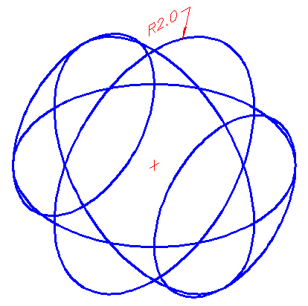

A Sphere is a globe-like shape. It is very similar to drawing a circle in that you pick a center point and then input either the radius (default) or diameter. Both methods draw the same sphere in the following examples:

**Command: SPHERE  
Specify center point or [3P/2P/Ttr]: <PICK POINT>  
Specify radius or [Diameter] <2.3756>: 6 <ENTER>**

**Command: SPHERE  
Specify center point or [3P/2P/Ttr]: <PICK POINT>  
Specify radius of sphere or [Diameter]:D  
Specify Diameter: 12**

Both of the above methods will give you the same result.

You also have the options of selecting 3 Points, 2 Points, or using 2 tangents and radius (TTR).

**Cylinder**  
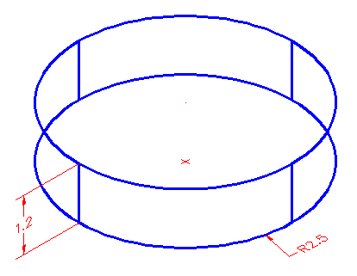

A cylinder is just like an extruded circle. Creating one is very similar to creating a circle, except that you are giving depth to it.

These two examples would draw the same cylinder:

**Command: CYLINDER  
Current wire frame density: ISOLINES=4  
Specify center point for base of cylinder or [Elliptical] <0,0,0>:<PICK POINT>  
Diameter/<Radius>: 2.5  
Center of other end/<Height>: 1.2**

**Command: CYLINDER  
Current wire frame density: ISOLINES=4  
Specify center point for base of cylinder or [Elliptical] <0,0,0>:<PICK POINT>  
Specify radius for base of cylinder or [Diameter]: D  
Diameter: 5  
Specify height of cylinder or [Center of other end]: 1.2**

**Cone**

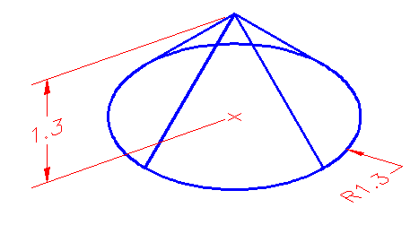

Drawing a cone is the same as drawing a cylinder, except that the resulting object tapers smoothly from the bottom to a point at the top.

**Command: CONE  
Current wire frame density: ISOLINES=4  
Specify center point for base of cone or [Elliptical] <0,0,0>:  
Specify radius for base of cone or [Diameter]: 4  
Specify height of cone or [Apex]: 8**

**Command: CONE  
Current wire frame density: ISOLINES=4  
Specify center point for base of cone or [Elliptical] <0,0,0>:  
Specify radius for base of cone or [Diameter]: D  
Specify diameter for base of cone: 8  
Apex/<Height>: 8**

Another way of drawing a cone is to enter in the center point, the radius (or diameter) and then establish where you want the apex (point of cone) to be. You can either type in coordinate points or pick a point with your cursor.

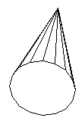

**Command: CONE  
Current wire frame density: ISOLINES=4  
Specify center point for base of cone or [Elliptical] <0,0,0>:<PICK>  
Specify radius for base of cone or [Diameter]: 5  
Specify height of cone or [Apex]: A  
Specify apex point: @5,5,6**

**Wedge**

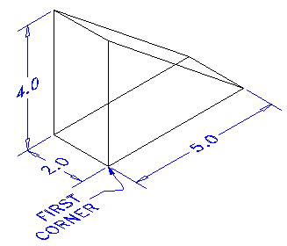

One of the trickier primitives to draw is the wedge. You have to be careful which coordinates you input to make the wedge lie in the position you want. If it doesn't turn out just as you hoped for, you can always rotate it.

Here is an example of drawing a wedge:

**Command: WEDGE   
Specify first corner of wedge or [CEnter]<0,0,0>: <PICK>  
Specify corner or [Cube/Length]: @5,2,4**

Once the first corner is established, you can either enter points, or pick a spot. AutoCAD will draw the shape like it would draw a cube except it is slice in half along the length starting at the point above the first corner. There are other options to drawing wedges and see the box examples for these.

**Torus**

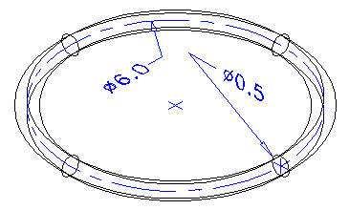

A torus is a donut-like shape or something resembling an inner tube. When drawing one you have to enter the center point, a radius to the center of the tube and the radius of the tube itself.

**Command: TORUS  
Current wire frame density: ISOLINES=4  
Specify center of torus <0,0,0>:  
Specify radius of torus or [Diameter]: 3  
Specify radius of tube or [Diameter]:.25**

The diagram above shows the resulting diameters from the input above. A center mark indicates the picked center of the torus.

**Pyramid**

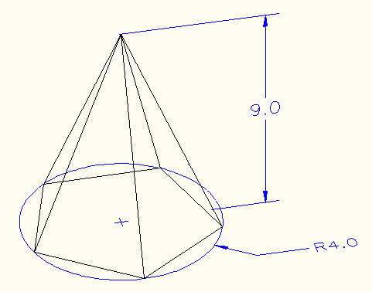

To draw a pyramid, you need to know the diameter of the base and the height. The diameter can either be inscribed (inside the circle) or circumscribed (outside the circle). You can define the number of edges to from 3 to 32.

**Command: PYR  
PYRAMID  
5 sides Inscribed  
Specify center point of base or [Edge/Sides]:  
Specify base radius or [Circumscribed] <4.5655>: C**

**Specify base radius or [Inscribed] <4.5655>: I**

**Specify base radius or [Circumscribed] <4.5655>: 4**

**Specify height or [2Point/Axis endpoint/Top radius] <10.0108>: 9**

In the above example, I showed how to switch between Inscribed or Circumscribed as the options change depending upon the method selected.

Try creating some pyramids using a variety of methods.

**Polysolid**

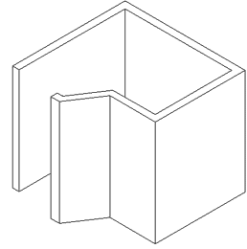

This is a new command since AutoCAD 2007. A polysolid allows you to draw a solid object while defining the height and the width. I think this command is aimed at the architects, who will enjoy the ability to quickly draw solid walls.

**Command: PSOLID   
POLYSOLID Specify start point or [Object/Height/Width/Justify] <Object>: H   
Specify height <96.0000>: 96  
Specify start point or [Object/Height/Width/Justify] <Object>: W   
Specify width <6.0000>: 6  
Specify start point or [Object/Height/Width/Justify] <Object>: J   
Enter justification [Left/Center/Right] <Center>: L   
Specify start point or [Object/Height/Width/Justify] <Object>: <Pick 1st point>**

**REVIEW**  
As mentioned in previous lessons, solids are usually the way to go with 3D CAD. Depending upon your chosen field, you may use 3D meshes in Civil Drafting, Isometric in HVAC, solids in mechanical, etc.   
I recommend getting used to solids if you are doing any kind of mechanical drafting or architectural drafting if you are using base AutoCAD software. When using solids, you will usually take a shape and extrude it - then use Boolean commands and others to edit it. Here is a basic building that was quickly drawn using a variety of primitive solids.

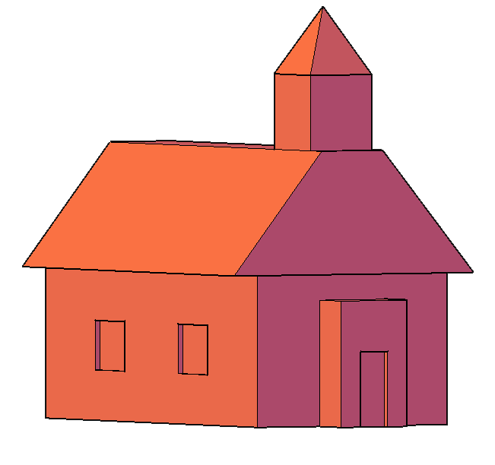

**Union | Subtract | Intersect | Extrude Face | Slice | 3D align**

Working in 3D usually involves the use of solid objects. At times you may need to combine multiple parts into one, or remove sections from a solid. AutoCAD has some commands that make this easy for you. These are the boolean operations as well as some other helpful commands for solids editing:

|  |  |  |  |
| --- | --- | --- | --- |
| **COMMAND** | **INPUT** | **ICON** | **DESCRIPTION** |
| UNION (Boolean) | UNION / UNI | Box Icon | Joins two or more solids into creating one based on the total geometry of all. |
| SUBTRACT (Boolean) | SUBTRACT / SU | Sphere Icon | Subtracts one or more solids from another creating a solid based on the remaining geometry. |
| INTERSECT (Boolean) | INTERSECT / IN | Cylinder Icon | Creates a single solid from one more solids based on the intersected geometry. |
| EXTRUDE FACE | SOLIDEDIT | Cone Icon | Allows you to increase the size of a solid by extruding out one of its faces. |
| SLICE | SLICE | Slice Icon | Slices a solid along a cutting plane. |
| 3D ALIGN | 3DALIGN | 3D Align Icon | Aligns 2 3D Objects in 3D space. |

The boolean commands work only on solids or regions. They are easy to work with *IF* you follow the command line prompts. Here is an example of each.

Start these exercises by drawing a box 5W X 7L X 3H and a cylinder 3 units in diameter so that the center of the circle is on the midpoint of the block.

**UNION**

Below left, there is a box and a cylinder. These are two separate objects. If you want to combine them into one object, you have to use the union command.

|  |  |
| --- | --- |
| Before Union | After Union |
| The UNION command combines one or more solid objects into one object. | |

Here are the command line prompts and the resulting object:

**Command: UNION <ENTER>  
Select objects: <SELECT THE BLOCK> 1 found  
Select objects: <SELECT THE CYLINDER> 1 found  
Select objects: <ENTER>**

NOTE: The object that you select **first** will determine the properties of the unioned object when it is created.

**SUBTRACT**

The subtract command is used to cut away, or remove the volume of one object from another. It is important to check the command line when using this command. Remember that AutoCAD always asks for the object that you are subtracting **FROM** first, then it asks for the objects to subtract. Here is an example:

|  |  |
| --- | --- |
| Before Subtract | After Subtract |
| The SUBTRACT command removes the volume of one or more solid objects from an object. | |

**Command: SUBTRACT  
Select solids and regions to subtract from...  
Select objects: <SELECT THE BLOCK> 1 found <ENTER>  
Select objects: Select solids and regions to subtract...  
Select objects: <SELECT THE CYLINDER> 1 found <ENTER>  
Select objects: <ENTER>**

You can also Subtract any number of solids from a number of solids. If you do this, the solids that you subtracted from will become ONE object - even if they are not touching. Be careful with this (although you can always slice the object if you need to).

**INTERSECT**

This command creates a new solid from the intersecting volume of two or more solids or regions. AutoCAD will find where the two objects have an volume of interference and retain that area and discard the rest. Here is an example of this command shown below:

|  |  |
| --- | --- |
| Before Intersect | After Intersect |
| The INTERSECT command combines the volume of one or more solid objects at the areas of interference to create one solid object. | |

**Command:INTERSECT  
Select objects: <SELECT THE BLOCK> 1 found  
Select objects: <SELECT THE CYLINDER> 1 found  
Select objects: <ENTER>**

You can intersect solids that are not touching - they will become one object.

Try these 3 boolean commands with various 3D solid objects to get familiar with them. Draw the outline of a block, extrude it - then draw the circle and extrude it. Then subtract the circle from the block.

These commands will allow you do a lot of 3D work, using only the extrude and these boolean commands. Of course, there are some other ways to edit 3D solids.

**Slice**

This command does exactly what the name implies. You can slice a 3D solid just like you were using a knife.

Start with the basic block and cylinder shape you used in the examples above.

|  |  |
| --- | --- |
| Slice Pickpoints | Slice Result |
| The INTERSECT command combines the volume of one or more solid objects at the areas of interference to create one solid object. | |

**Command: SLICE   
Select objects: 1 found  
Select objects: Specify first point on slicing plane by   
[Object/Zaxis/View/XY/YZ/ZX/3points] <3points>: <PICK POINT 1>  
Specify second point on plane: <PICK POINT 2>  
Specify third point on plane: <PICK POINT 3>  
Specify a point on desired side of the plane or [keep Both sides]: <Pick on the side towards the cylinder>**

This is a very useful command - think of it as a trim in 3D. Make sure you have your Osnaps on for this command and that you pick the correct points. In a complex 3D drawing, this can be tough to see. Undo this slice and try picking 3 other points. See if the results match what you thought they would do.

**Extrude face**

Just as there is a "trim"-like command in 3D - there is also a "stretch". This is a new command in recent versions.

I usually start this command by clicking on the Ribbon item Home > Solids Editing > Extrude Faces.

The command is quite easy to use, but you need to be careful on which face you select.

Try to extend one edge of the block by 1 inch. Start the command and pick the face on the side (on the bottom line). You'll notice that the bottom face highlights as well. Next type R and pick the bottom face to remove it. Then follow the command line to finish the command.

**Command: _solidedit  
Solids editing automatic checking: SOLIDCHECK=1  
Enter a solids editing option [Face/Edge/Body/Undo/eXit] <eXit>: F  
Enter a face editing option  
[Extrude/Move/Rotate/Offset/Taper/Delete/Copy/coLor/Undo/eXit] <eXit>: E  
Select faces or [Undo/Remove]: <PICK BOTTOM LINE OF SIDE FACE> 2 faces found.  
Select faces or [Undo/Remove/ALL]: R  
Remove faces or [Undo/Add/ALL]:<PICK AN EDGE ON THE BOTTOM FACE> 2 faces found, 1 removed.  
Remove faces or [Undo/Add/ALL]:<ENTER>  
Specify height of extrusion or [Path]: 1 <ENTER>  
Specify angle of taper for extrusion <0>: <ENTER>  
Solid validation started.  
Solid validation completed.  
Enter a face editing option  
[Extrude/Move/Rotate/Offset/Taper/Delete/Copy/coLor/Undo/eXit] <eXit>:<ENTER>**

You should end up with this:

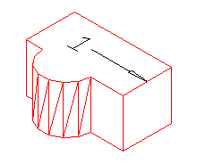

Another way of editing faces in AutoCAD 2007 and newer is to use grips to extrude the faces, just like you would on a 2D object. Here is an image below that shows some of the grips available. This option is only available on the basic shapes.

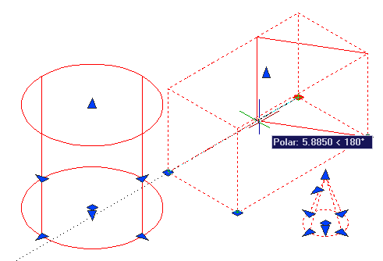

**3D align**

Sometimes, you may find it faster or easier to draw something separately and then move and align it into place. The command to use this in 3D is (funnily enough) 3DALIGN.

This is a simple example, but will show you the method.

Draw a box that is 5 x 5 x 6 tall. Next draw a cylinder that is 3 in diameter and 1 tall. It should look like this:

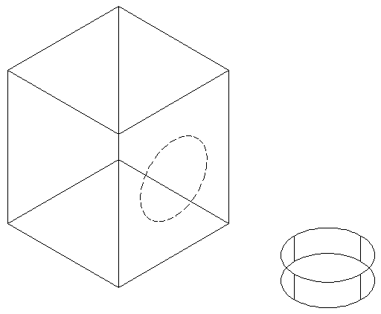

The goal will be to align the cylinder on the front face of the box where the dotted line is.

Turn on your quadrant Osnaps. Start the 3DALIGN command. You will first be asked to select the objects - select the cylinder and press enter.

Now you will be asked to select the 3 points as indicated below: the center and 2 quadrants. Now the cylinder will be "stuck" to your cursor as AutoCAD asks where it needs to go.

Line the cylinder up with the box by using object tracking to locate the center of the face on the box first. Then pick on the midpoints to line up the cylinder to the box. After you pick the 3rd point, the cylinder should move into place and end the command.

Here's a view of the points that were picked incase you had trouble.

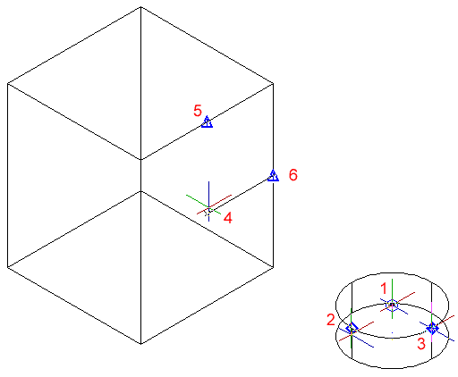

The finished 'alignment job' should look like this after using the hide command.

